(ADJUSTED TRAIL BALANCE & FINANCIAL STATEMENTS)
Question 1
XYZ Inc., provides employment consulting services. The company adjusts its accounts monthly but performs closing entries annually on December 31. The unadjusted trail balance is as follows:
XYZ
UNADJUSTED TRAIL BALANCE
AS ON 31-12-2011
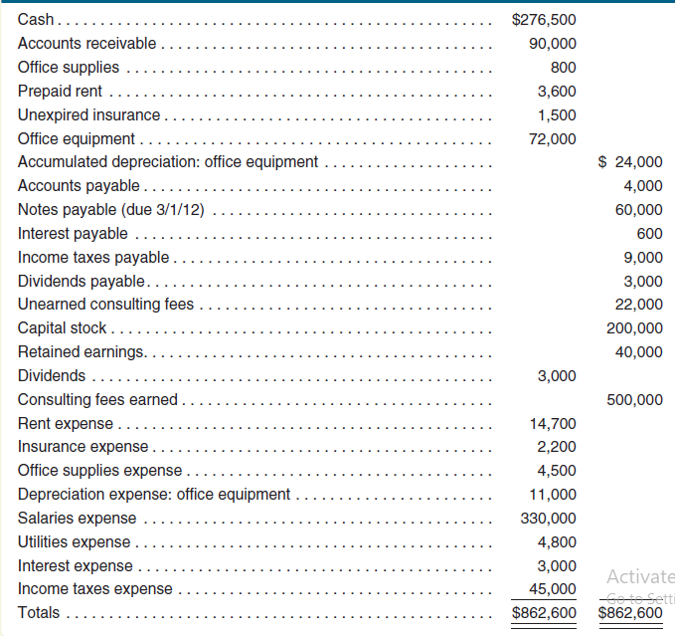
THE FOLLOWING ADJUSTEMENTS ARE REQUIRED AT YEAR END:
(1) Accrued consulting fee:
It means income due but not received as yet till the reporting date

Accrued but unrecorded consulting fees earned total $20,000 at December 31, 2011.
Debit: accounts receivable 20000
Credit: consulting fee earned 20000

(2) Unearned (consulting fee):
It means fee was received in advance but we have to give services to the other party.

The company determined that $10,000 of previously unearned consulting services fees had been earned at December 31, 2011.
Debit: UNEARNED CF 10000
Credit: CF EARNED 10000

(3) Office supplies (Current asset)
These are current assets. As we use them we need to expense them.

Office supplies on hand at December 31 total $200 (800 – 200) 600
Debit: OS EXPENSE 600
Credit: OS 600

(4) Equipment (Non-Current Asset) & depreciation)
Depreciation needs to be recorded on non-current assets at each year end

The company purchased all of its equipment when it first began business. At that time, the estimated useful life of the equipment was 5 years (60 months).
72000/60 = 1200 PER MONTH X 12 MONTH = 14400
Debit: DEP EXP 14400
Credit: ACCUMULATED DEP 14400

(5) Prepaid rent expense
It means rent paid in advance but benefit yet to be received

The company prepaid its ten-month rent agreement on June 1, 2011.
3600/10 = 360 X 7 MONTHS= 2520
Debit: RENT EXP 2520
Credit: PREPAID RENT 2520

(6) Prepaid/Unexpired insurance expense
It means insurance paid in advance but benefit yet to be received
The company prepaid its ten-month insurance policy on December 1, 2011.
1500/10 = 150 X 1 MONTH = 150
Debit: INS EXP 150
Credit: PREPAID / UNEXPIRED INS 150

(7) Accrued salaries expense
It means salaries due but not paid by the company

Accrued but unpaid salaries total $20,000 at December 31, 2011.
Debit: SALARIES EXP 20000
Credit: SALARIES PAYABLE 20000

(8) Interest on loan
Interest on loan needs to be recorded at balance sheet date as an expense and liability

On September 1, 2011, the company borrowed $60,000 by signing a seven-month, 3 percent note payable. The entire amount, plus interest, is due on April 1, 2012.
60000 X 3% = `1800 PER ANNUM X 4/12 = 600
Debit INT EXP 600
Credit: INT PAYABLE 600

(9) Taxation
Tax needs to be recorded at balance sheet date as an expense and liability

Company’s accounting firm estimates that income taxes expense for the entire year is $40,000. The unpaid portion of this amount is due early in 2012.

Debit: TAX EXPENSE 40000
Credit: TAX PAYABLE 40000

ADJUSTED TRAIL BALANCE

Accounts | Debit ($) | Credit ($)
Cash 276500
Accounts receivable 90000 +20000
Office supplies 800 -600
Prepaid rent 3600 -2520
Unexpired insurance 1500 - 150
Office equipment 72000
Accumulated depreciation (office equipment) 24000+14400
Accounts payable 4000
Notes payable 60000
Interest payable 600 +600
Income tax payable 9000 +40000
Dividend payable 3000
Unearned consulting fees 22000 -10000
Salaries payable 0 +20000
Capital stock 200000
Retained earnings 40000
Dividends paid 3000
Consulting fees earned 500000 +20000 +10000
Rent expense 14700 + 2520
Insurance expense 2200 +150
Office supplies expense 4500 + 600
Depreciation expense (office equipment) 11000 +14400
Salaries expense 330000 +20000
Utilities expense 4800
Interest expense 3000 +600
Income tax expense 45000 +40000
Total

Income Statement
($)
Revenue:
Consulting fee earned
Expenses:
Rent
Insurance
Office supplies expense
Depreciation: office supplies
Salaries
Utilities
Interest
income before tax
Tax expense
Net income

Statement of Retained Earnings

($)
Opening balance retained earnings (from adjusted TB)
+ Net income
- Dividends
Closing balance retained earnings

Balance Sheet
($)
Assets:
Cash
Accounts receivable
Office supplies
Prepaid rent
Unexpired insurance
Office equipment less: Accumulated depreciation
Total assets
Liabilities:
Accounts payable
Notes payable
Interest payable
Income tax payable
Dividend payable
Salaries payable
Unearned consulting fee
Total liabilities
Equity
Capital stock
Closing balance retained earnings
Total liabilities & Equity

